***Movie Recommendation System***

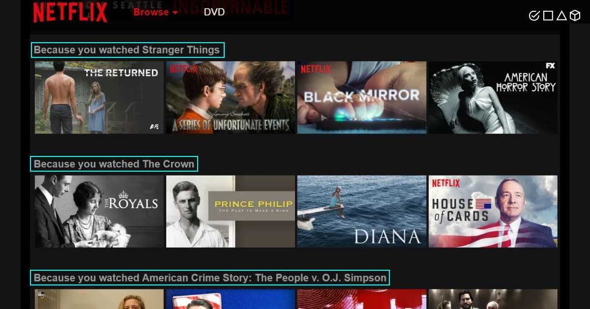

The basic concept behind a movie recommendation system is quite simple. In particular, there are two main elements in every recommender system: users and items. The system generates movie predictions for its users, while items are the movies themselves.

The primary goal of movie recommendation systems is to filter and predict only those movies that a corresponding user is most likely to want to watch. The ML algorithms for these recommendation systems use the data about this user from the system’s database. This data is used to predict the future behavior of the user concerned based on the information from the past.

**Filtration Strategies for Movie Recommendation Systems:**

*Movie recommendation systems use a set of different filtration strategies and algorithms to help users find the most relevant films. The most popular categories of the ML algorithms used for movie recommendations include content-based filtering and collaborative filtering systems.*

* ***Content-Based Filtering***

A filtration strategy for movie recommendation systems, which uses the data provided about the items (movies). This data plays a crucial role here and is extracted from only one user. An ML algorithm used for this strategy recommends motion pictures that are similar to the user’s preferences in the past. Therefore, the similarity in content-based filtering is generated by the data about the past film selections and likes by only one user.

How does it work? The recommendation system analyzes the past preferences of the user concerned, and then it uses this information to try to find similar movies. This information is available in the database (e.g., lead actors, director, genre, etc.). After that, the system provides movie recommendations for the user. That said, the core element in content-based filtering is only the data of only one user that is used to make predictions.

* ***Collaborative Filtering***

As the name suggests, this filtering strategy is based on the combination of the relevant user’s and other users’ behaviors. The system compares and contrasts these behaviors for the most optimal results. It’s a collaboration of the multiple users’ film preferences and behaviors.

What’s the mechanism behind this strategy? The core element in this movie recommendation system and the ML algorithm it’s built on is the history of all users in the database. Basically, collaborative filtering is based on the interaction of all users in the system with the items (movies). Thus, every user impacts the final outcome of this ML-based recommendation system, while content-based filtering depends strictly on the data from one user for its modeling.

How to Build a Movie Recommendation System?

Once we’ve discussed the basics of film recommendation engines in machine learning, we can move on to building an actual movie recommendation system. So, we need to build an engine that learns and recognizes patterns in a user’s viewing history before using these patterns to generate new recommendations. What’s required for this?

* *Data:* ML systems need data, so find and import the essential libraries with movie datasets that already have global ratings.
* *Analysis*: Create generic recommendations of top-rated movies from the existing dataset.
* *Personalization:* Get personalized ratings by providing your own movie scores.

Strategy. Implement content-based or collaborative filtering strategy.

* *Combination:* Combine recommendation lists to get a reasonable estimate across the ratings. The combined dataset of movie ratings can now be used for either filtering model.